FAO: Jo Graham – Cathedral House Office, St John the Baptist RC Cathedral Unthank Road, Norwich NR2 2PA
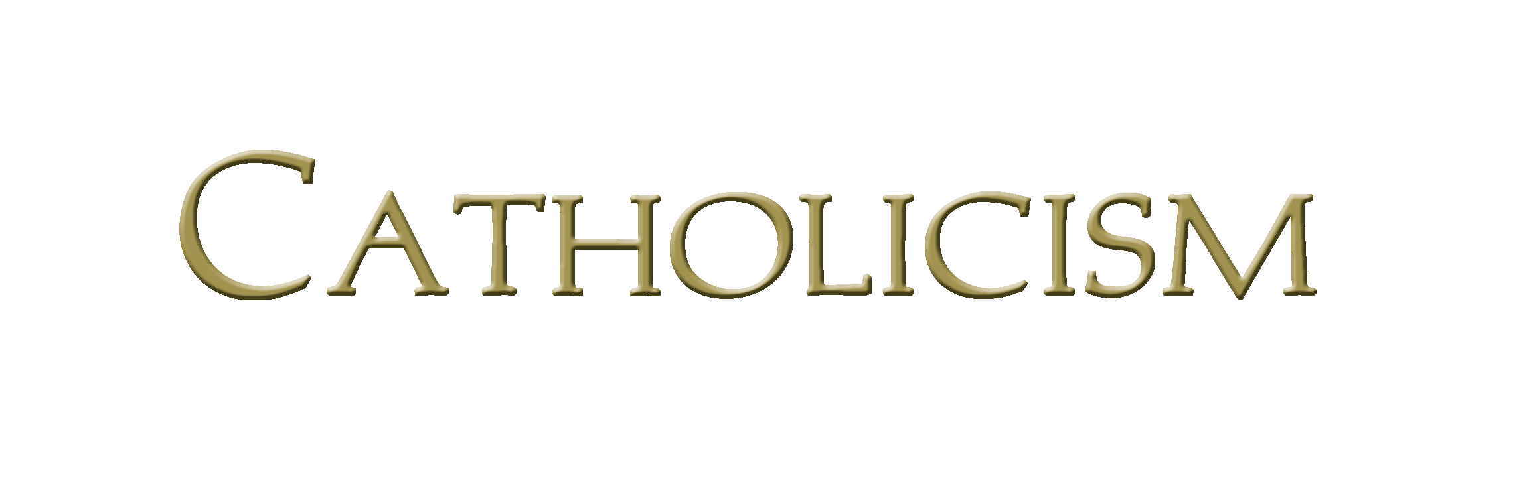
Bishop Robert Barron’s Catholicism Series Study Program Registration

To register for the upcoming Catholicism Series program, please complete this form and return it to the Cathedral House Office by 17 September 2017. Thank you.

Name __________________________________________________________________________________

Address________________________________________________________________________________

Post Code ______________________Preferred phone number: ___________________________

Email address: ________________________________________________________________________

Have you ever participated in a formation program? _________ Yes ________ No

If more than one person in your family is attending, please provide numbers

Adults___________________ Under 16s_________________ Under 12s_________________
(Children are very welcome and there will be suitable activities to keep them occupied during the talks)

_______________________________________________________________________________________________________________

Catholicism Series – save the dates:

Friday evenings – 7.30 – 9.00pm in Mac’s Bar on

- 22 September
- 29 September
- 6 October
- 13 October
- 20 October
- 3 November
- 10 November
- 17 November
- 24 November
- 1 December

*No talk on 27 October due to the Candlelight Procession from Castle Musuem and all-night Vigil

